DSA 0601 - Data handling and visualization
Set 19 - Survey Responses Analysis
Name : B.Jahnavi
Reg.no:192325043

- Grouped bar chart
Code:

library(ggplot2)
survey <- data.frame(
Survey_ID = c(1, 2, 3),
Question_1 = c("A", "B", "C"),
Question_2 = c("B", "A", "A"),
Question_3 = c("C", "D", "B")
)

ggplot(survey, aes(x = Question_1, fill = Question_1)) +
geom_bar() +
labs(
title = "Distribution of Responses for Question 1",
x = "Answer",
y = "Number of Responses",
fill = "Response"
) +
theme_minimal()

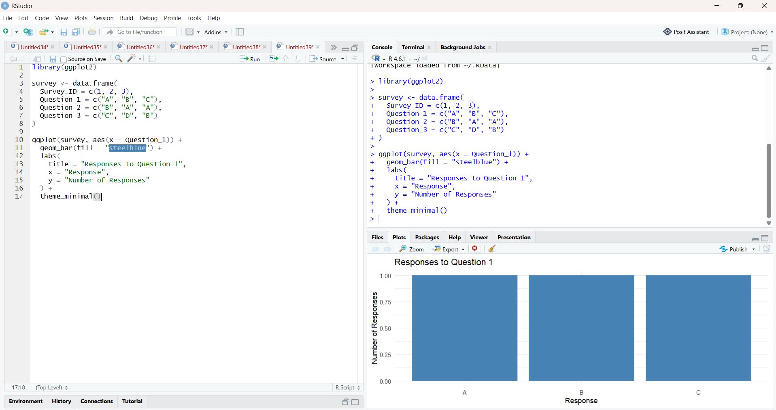

2. Stacked bar chart for all three questions
Code:

library(ggplot2)
library(tidyr)
survey_long <- pivot_longer(
survey,
cols = starts_with("Question"),
names_to = "Question",
values_to = "Response"
)
ggplot(survey_long, aes(x = Question, fill = Response)) +
geom_bar() +
labs(
title = "Overall Distribution of Survey Responses",
x = "Survey Question",
y = "Number of Responses",
fill = "Answer"
) +
theme_minimal()

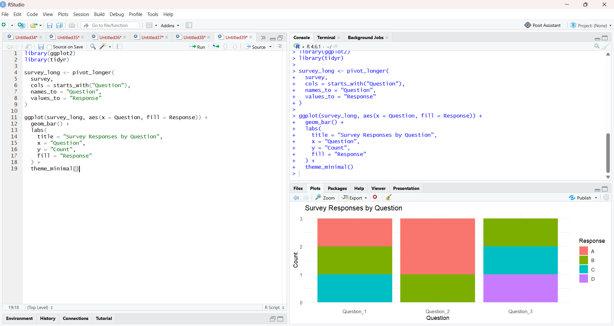

3. Table of survey responses
Code:

library(knitr)

kable(
survey,
caption = "Survey Response Data",
col.names = c("Survey ID", "Question 1", "Question 2", "Question 3")
)

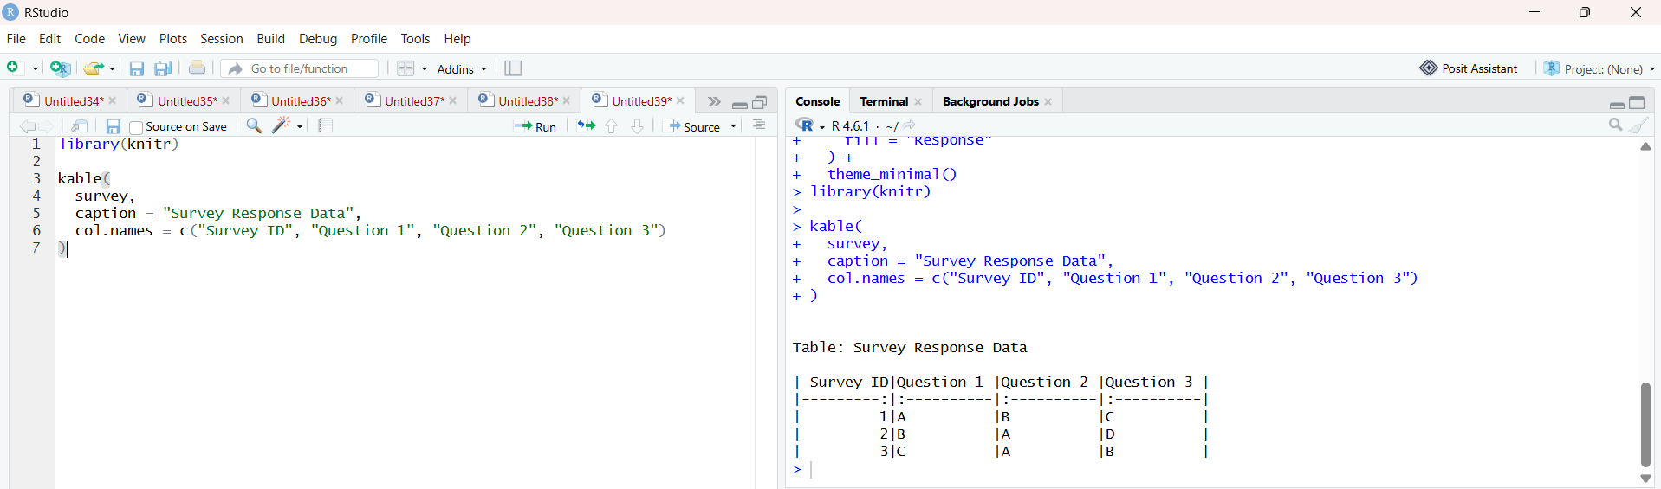

4.Tableau dashboard
Code:

survey <- data.frame(
Survey_ID = c(1, 2, 3),
Question_1 = c("A", "B", "C"),
Question_2 = c("B", "A", "A"),
Question_3 = c("C", "D", "B")
)
write.csv(survey, "Set19_Survey.csv", row.names = FALSE)

